Colney Heath
During the 1939 – 1945 War
A Childs Memories

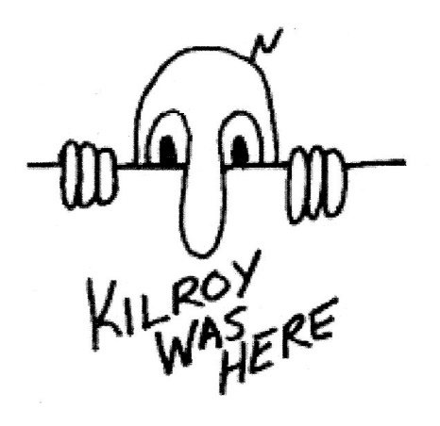

By
George Stuchbery

The cartoon figure on the front cover was used during the war to expose shortages such as “wot no bananas” or “what no butter” etc
The catch phrase “Kilroy was here” was used by an American inspector in a ship yard to denote he had inspected the work on this part of the ship. This was seen in English ship yards and became a popular slogan .

